**Section 30 Angular 6 changes and New Features**

**Section 30: Lecture 391//What Changed with Angular 6**

1. 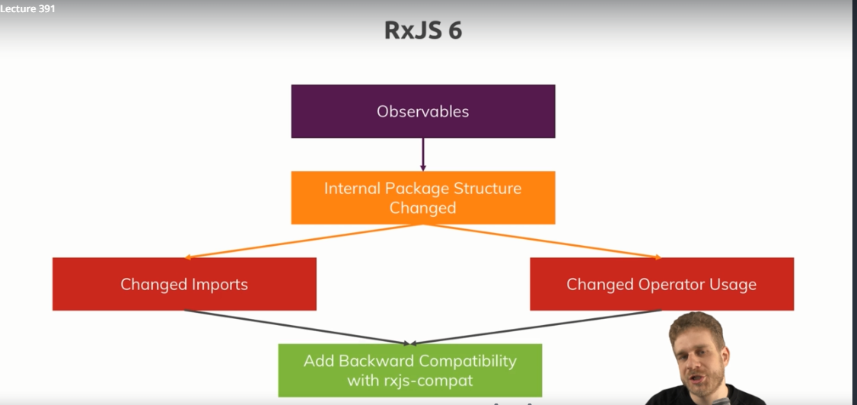
2. 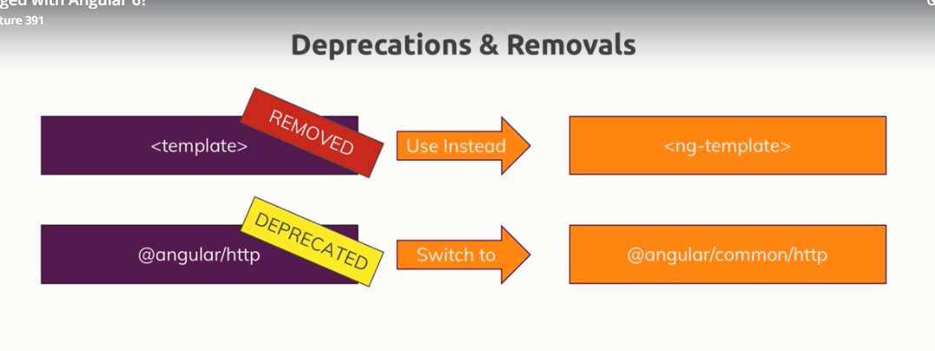
3. 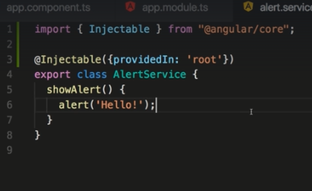
4. 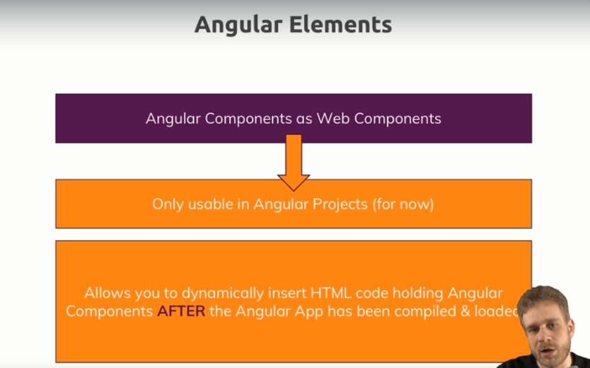
5. 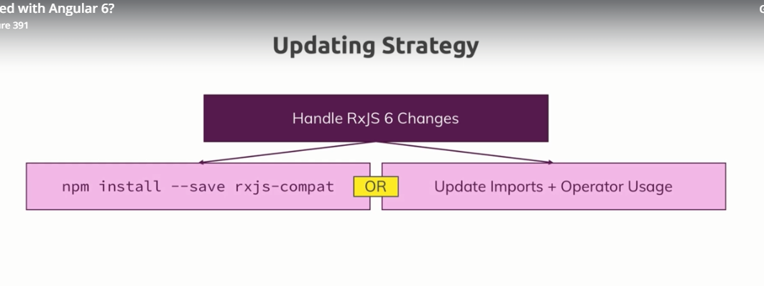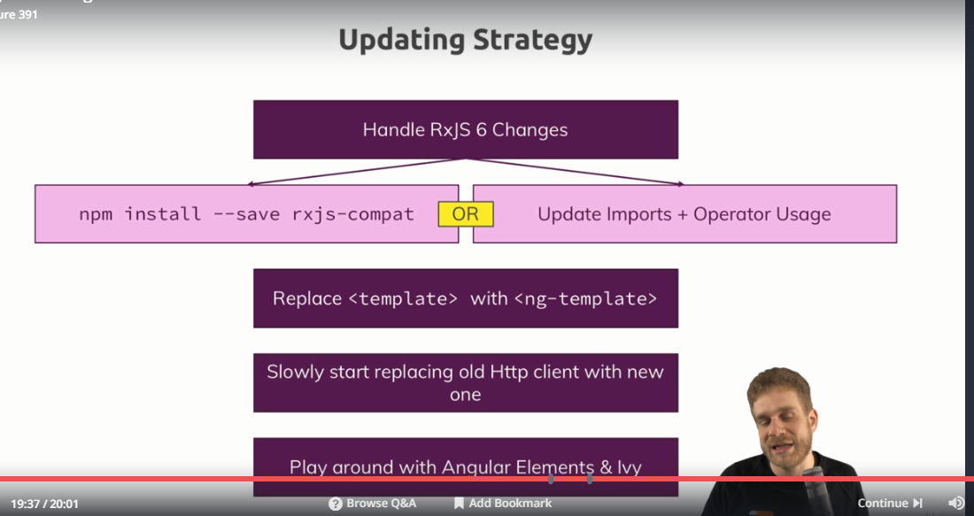

**Section 30: Lecture 392//A first Look at Angular Elements**